**SUMMER TRAINING REPORT**

NTPC – AURAIYA GAS POWER STATION

JUNE-JULY 2023

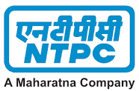

A Project Report submitted by

**NANDINI YADAV**

On

Information Technology



DIT UNIVERSITY, Dehradun

*Under supervision of*

**Mr. S.C MEENA**

**(Senior Manager)**

**Training Mentor**

**CONTENTS**

|  |  |  |
| --- | --- | --- |
| SERIAL NO. | TOPIC | PAGE NO. |
| 1. | INTRODUCTION | 3 |
| 2. | TOTAL INSTALLED CAPAPCITY OF NTPC | 4 |
| 3. | INTRODUCTION TO NTPC POWER PLANT – AURAIYA | 5 |
| 4. | Purpose of this report | 6 |
| 5. | Introduction to the IT department of NTPC : | 8 |
| 6. | MANAGEMENT INFORMATION SYSTEMS | 9 |
| 7. | Consultancy for development of Local Area Network /Wide Area Network | 11 |
| 8. | Consultancy for satellite communication | 13 |
| 9. | Computerization of O&M and Material management manuals | 15 |
| 10. | Field attachment activities | 17 |
| 11. | Installation of Windows 7 | 21 |
| 12. | Failed boot | 27 |
| 13. | Wide Area Network | 32 |
| 14. | Virtualisation and cloud computing | 34 |
| 15. | VBLOCK system | 37 |
| 16. | Local Area Network (cables) | 38 |
| 17. | WLAN | 41 |
| 18. | Data Acquisition System | 42 |
| 19. | Lessons and Experiences | 45 |
| 20. | Conclusion | 47 |

INTRODUCTION

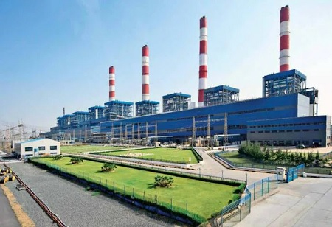

**Figure: Image from main plant NTPC**

**NTPC Limited**, formerly known as *National Thermal Power Corporation*, is an Indian [central Public Sector Undertaking](https://en.wikipedia.org/wiki/Public_sector_undertakings_in_India) under the ownership of the [Ministry of Power](https://en.wikipedia.org/wiki/Ministry_of_Power_(India)), [Government of India](https://en.wikipedia.org/wiki/Government_of_India) which is engaged in [generation of electricity](https://en.wikipedia.org/wiki/Electricity_generation) and allied activities. The headquarters of the PSU are situated at [New Delhi](https://en.wikipedia.org/wiki/New_Delhi). NTPC's core function is the generation and distribution of electricity to State Electricity Boards in India. The body also undertakes consultancy and turnkey project contracts that involve engineering, project management, construction management, and operation and management of power plants.

It is the largest power company in India with an electric power generating capacity of 71,594 MW.[[5]](https://en.wikipedia.org/wiki/NTPC_Limited#cite_note-AR201213-5) Although the company has approximately 16% of the total national capacity, it contributes to over 25% of total power generation due to its focus on operating its power plants at higher efficiency levels (approximately 80.2% against the national [PLF](https://en.wikipedia.org/wiki/Plant_load_factor) rate of 64.5%). NTPC currently produces 25 billion units of electricity per month.

It was founded by [Government of India](https://en.wikipedia.org/wiki/Government_of_India) in 1975, which now holds 51.1% of its equity shares[[6]](https://en.wikipedia.org/wiki/NTPC_Limited#cite_note-ReferenceA-6) (after divestment of its stake in 2004, 2010, 2013, 2014, 2016, & 2017)  
In May 2010, NTPC was conferred [Maharatna](https://en.wikipedia.org/wiki/Maharatna" \o "Maharatna) status by the Union Government of India, one of only four companies to be awarded this status.[[7]](https://en.wikipedia.org/wiki/NTPC_Limited#cite_note-7) It is ranked 400th in the [Forbes Global 2000](https://en.wikipedia.org/wiki/Forbes_Global_2000) for 2016.

**TOTAL INSTALLED CAPAPCITY OF NTPC**

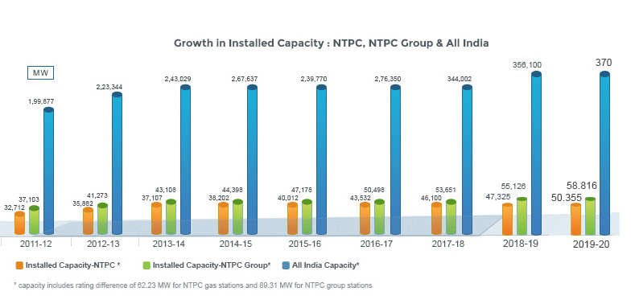

The total installed capacity of the company is 72,364 MW (including JVs) own stations include 23 coal based,  7 gas based, 1 Hydro 1 Wind 18 Solar and 1 Small hydro plant. Under JV, NTPC has 9 coal based, 4 gas based, 8 hydro based and 5 renewable energy projects. The capacity will have a diversified fuel mix and by 2032, non fossil fuel based generation capacity shall make up nearly 30% of NTPC’s portfolio.

NTPC has been operating its plants at high efficiency levels. As on 31.03.2020 the company had 16.78% of the total national capacity and, it contributes 20.96% of total power generation due to its focus on high efficiency.

NTPC is not only the foremost power generator; it is also among the great places to work. The company is guided by the “People before Plant Load Factor” mantra which is the template for all its human resource related policies. In 2019, NTPC is recognized as “Laureate” for consistently ranking among “Top 50 Best Companies to Work for in India” for last 11 years in the Great Place to Work and Economic Times survey. Besides, NTPC was also recognized as the best among PSUs and in Manufacturing.

**INTRODUCTION TO NTPC POWER PLANT – AURAIYA**



NTPC Auraiya is located at Dibiyapur in Auraiya district in the Indian state of Uttar Pradesh. The power plant is one of the gas-based power plants of NTPC. The gas for the power plant is sourced from GAIL HBJ Pipeline – South Basin Gas field.

Purpose of this report

The purpose of this report is to highlight the key aspects of IT in supporting the operations, management, and efficiency of the power station.

1. IT Infrastructure:

• Hardware: The NTPC Power Station maintains a robust hardware infrastructure, including servers, data storage systems, networking equipment, and computer workstations, to support its IT operations.

• Software: A range of software applications is utilized, such as operating systems, databases, security tools, enterprise resource planning (ERP) systems, and specialized software for power plant operations and maintenance.

2. Network Infrastructure:

• Local Area Network (LAN): The power station is equipped with a LAN that interconnects various departments, enabling the sharing of information, resources, and collaboration among employees.

• Wide Area Network (WAN): The WAN connects the power station to other locations, such as regional offices, corporate headquarters, and external stakeholders, facilitating communication, data transfer, and remote management.

3. Power Plant Automation:

• Supervisory Control and Data Acquisition (SCADA): The power station implements SCADA systems to monitor and control the plant's operations in real-time. SCADA enables the remote management of various processes, including power generation, equipment status monitoring, and alarm systems.

• Distributed Control System (DCS): DCS is used for controlling and monitoring specific processes within the power station, such as boiler operations, turbine control, and environmental monitoring.

4. Data Management and Analytics:

• Data Collection: The power station gathers data from sensors, meters, and control systems to capture information on various parameters, including power output, fuel consumption, emissions, and equipment performance.

• Data Storage and Integration: A centralized database system is employed to store and integrate data from multiple sources, ensuring data integrity and accessibility for analysis and reporting purposes.

• Data Analytics: Advanced analytics tools are utilized to extract insights from the collected data, enabling proactive maintenance, performance optimization, and decision-making based on historical trends and predictive models.

5. Cybersecurity:

• Security Measures: The power station employs comprehensive cybersecurity measures to protect its IT systems and critical infrastructure from potential threats, including firewalls, intrusion detection systems, encryption, and access control mechanisms.

• Regular Audits and Updates: Periodic security audits, vulnerability assessments, and system updates are conducted to address emerging threats and ensure the highest level of protection.

6. Training and Support:

• User Training: The power station provides regular training programs to enhance the IT skills of its employees, enabling them to effectively utilize the available technology and software applications.

• Technical Support: A dedicated IT support team is available to address technical issues, provide assistance, and troubleshoot any IT-related problems faced by the power station's staff.

In conclusion, the NTPC Power Station demonstrates a robust and well-implemented IT infrastructure to support its operations. The combination of hardware, software, networking, automation, data management, and cybersecurity measures ensures efficient power generation, effective plant control, and enhanced decision-making capabilities. Continuous investments in technology, training, and security reflect the power station's commitment to leveraging IT for improved efficiency and reliability.

**Introduction to the IT department of NTPC**

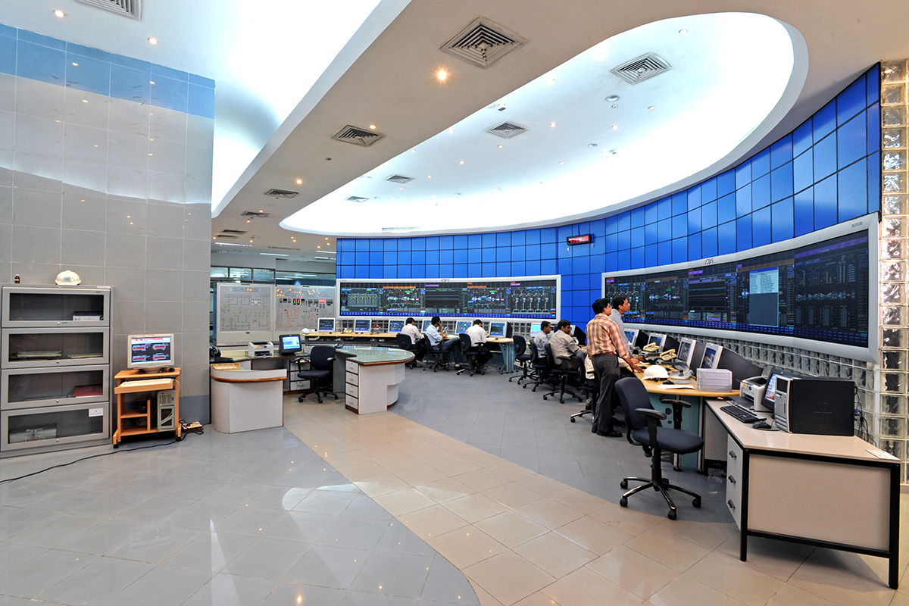

Bottom of Form

NTPC has integrated Information Technology as a strategic tool in its management systems.

Services covered under Information Technology include the following:

* Management Information Systems
* Consultancy for development of Local Area Network /Wide Area Network
* Consultancy for Satellite Communication Network
* Computerization of O&M and Material management manuals

**MANAGEMENT INFORMATION SYSTEMS**

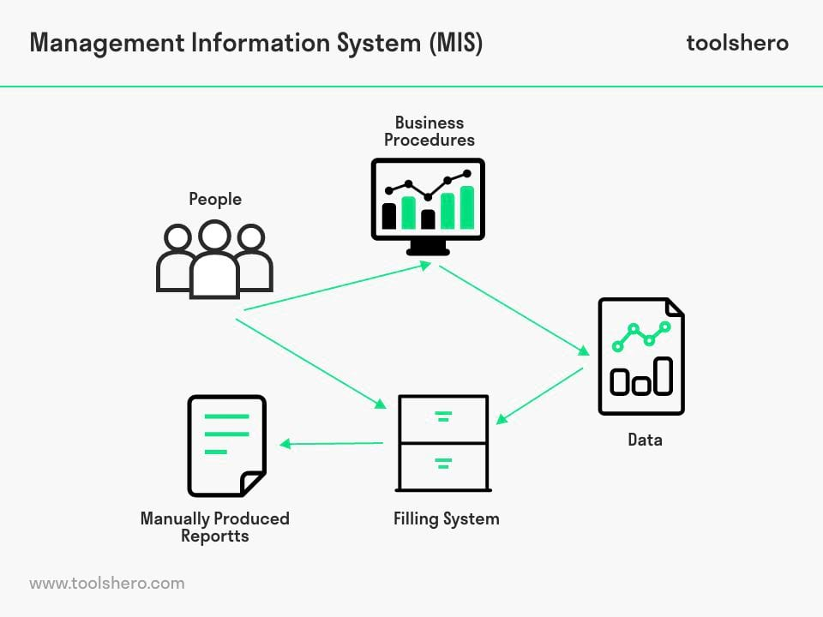

Management Information Systems (MIS) play a critical role in IT departments by facilitating the effective management of information and technology resources within an organization. Here are some key points to note about MIS in IT departments:

1. Definition and Purpose: Management Information Systems refer to the use of technology, people, and processes to gather, store, process, and distribute information to support decision-making, coordination, control, analysis, and visualization within an organization.

2. Data Management: MIS helps IT departments manage vast amounts of data generated within an organization. It involves activities such as data collection, storage, organization, integration, and retrieval, ensuring data quality and security.

3. Technology Infrastructure: MIS oversees the technology infrastructure within IT departments. This includes hardware, software, networks, and databases required to support the organization's information needs. MIS professionals ensure that systems are reliable, scalable, and secure.

4. Information Analysis: MIS leverages various tools and techniques to analyze and interpret data, transforming it into meaningful information for decision-making. This includes generating reports, conducting data mining, and utilizing business intelligence tools.

5. System Development and Integration: MIS plays a key role in developing and integrating information systems within IT departments. This involves assessing organizational requirements, designing and implementing software applications, and integrating different systems to ensure seamless flow of information.

6. IT Strategy and Planning: MIS contributes to the formulation of IT strategies and plans within an organization. It aligns technology initiatives with business goals, identifies opportunities for improvement, and assists in resource allocation and budgeting.

7. Security and Risk Management: MIS is responsible for managing information security and minimizing risks related to data breaches, unauthorized access, and system failures. This includes implementing security measures, conducting risk assessments, and ensuring compliance with regulations.

8. User Support and Training: MIS provides user support and training to ensure that employees can effectively utilize information systems. This includes troubleshooting issues, addressing user queries, and conducting training programs to enhance digital literacy and maximize system utilization.

9. Decision Support Systems: MIS supports decision-making processes by providing timely and accurate information to managers. Decision support systems assist in analyzing complex problems, generating alternatives, and evaluating potential outcomes, aiding in strategic and operational decision-making.

10. Continuous Improvement: MIS fosters a culture of continuous improvement within IT departments. It encourages the evaluation of existing systems, identification of opportunities for enhancement, and implementation of measures to optimize processes and outcomes.

Overall, Management Information Systems are instrumental in enabling IT departments to effectively manage information resources, support decision-making, and drive organizational success in an increasingly technology driven – era.

**Consultancy for development of Local Area Network /Wide Area Network**

Consultancy for the development of a Local Area Network (LAN) or Wide Area Network (WAN) involves providing expert advice and assistance to organizations in designing, implementing, and managing their network infrastructure.

A LAN refers to a network that covers a relatively small geographic area, such as an office building, campus, or a group of buildings. It is used to interconnect devices within a limited area, allowing for the sharing of resources, such as printers, file servers, and internet connections. A LAN typically uses Ethernet or Wi-Fi technologies for communication and is usually owned and managed by a single organization.

On the other hand, a WAN spans a larger geographical area and connects multiple LANs together, often over long distances. WANs are used to interconnect different offices, branches, or sites of an organization. They utilize various networking technologies, including leased lines, MPLS (Multiprotocol Label Switching), VPN (Virtual Private Network), and the internet, to enable communication between geographically dispersed locations.

When providing consultancy for LAN or WAN development, the following aspects may be addressed:

1. Network Design: Consultants analyze the organization's requirements, considering factors like the number of users, types of applications, expected traffic volume, and security needs. They create a network design plan that outlines the topology, equipment, and protocols required for optimal performance and scalability.

2. Hardware and Software Selection: Based on the network design, consultants recommend the appropriate networking equipment, such as routers, switches, firewalls, and servers. They also assist in selecting the right software components, including operating systems, network management tools, and security software.

3. Network Infrastructure Implementation: Consultants may assist in deploying the network infrastructure, including physical cabling, wireless access points, and network devices. They ensure that the installation follows industry best practices, adheres to relevant standards, and optimizes performance and reliability.

4. Network Security: Security is a critical aspect of any network. Consultants help identify potential vulnerabilities, design and implement security measures, such as firewalls, intrusion detection systems, and encryption protocols. They also provide guidance on network access controls, user authentication, and data protection strategies.

5. Network Performance Optimization: Consultants monitor and analyze network performance to identify bottlenecks, latency issues, or congestion. They recommend solutions for optimizing performance, such as traffic prioritization, Quality of Service (QoS) configurations, and network capacity planning.

6. Network Management and Maintenance: Consultants assist in establishing network management processes and tools for monitoring and maintaining the LAN or WAN. This includes implementing network monitoring systems, configuring backups and disaster recovery plans, and providing guidelines for ongoing network administration.

7. Troubleshooting and Support: In case of network issues or outages, consultants may offer troubleshooting assistance to identify and resolve problems promptly. They provide support services to ensure the smooth operation of the LAN or WAN and help organizations recover from network failures.

Overall, consultancy for LAN or WAN development aims to ensure that organizations have a robust, secure, and scalable network infrastructure that meets their specific needs and enables efficient communication and resource sharing among users and locations.Top of Form

**Consultancy for Satellite Communication Network**

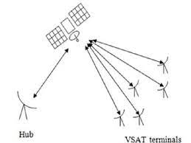

Requirement Gathering: The consultancy team meets with NTPC stakeholders to understand their communication needs and challenges. This includes identifying remote locations, connectivity requirements, data transfer rates, and specific applications that require satellite communication.

Feasibility Assessment: The consultants conduct a comprehensive analysis to determine the feasibility of satellite communication for NTPC. They consider factors like satellite coverage, bandwidth availability, latency, cost implications, regulatory compliance, and the integration of satellite communication with existing terrestrial networks.

Network Design: Based on the requirements and feasibility assessment, the consultancy team designs a network architecture for satellite communication. This includes selecting the appropriate satellite technology (geostationary or LEO satellites), determining dish sizes, planning for redundancy and resilience, and designing the network topology.

Vendor Evaluation: Consultants assist NTPC in evaluating and selecting the right vendors or service providers for satellite communication infrastructure. They assess vendors based on their track record, reliability, technical capabilities, and cost-effectiveness.

Equipment Selection: The consultancy team recommends the necessary satellite communication equipment and systems, such as satellite dishes, modems, routers, and network management tools. They consider factors like performance, scalability, compatibility, and cost-efficiency.

Implementation and Integration: Consultants oversee the implementation of the satellite communication infrastructure. This includes coordinating with vendors, managing equipment installation, configuring network settings, integrating satellite communication with existing networks, and conducting comprehensive testing.

Security and Compliance: The consultancy team ensures that the satellite communication network meets the required security standards and regulatory compliance. They assist in implementing encryption protocols, firewalls, access controls, and monitoring systems to safeguard data transmitted over the network.

Training and Documentation: Consultants provide training sessions to NTPC staff to ensure they are proficient in operating and managing the satellite communication network. They also create detailed documentation, including network diagrams, configurations, and troubleshooting procedures.

Ongoing Support: Consultants offer post-implementation support to address any issues, provide troubleshooting assistance, and help with network optimization. They may also assist with capacity planning, network monitoring, and periodic reviews to ensure the network continues to meet NTPC's evolving communication requirements.

Throughout the consultancy process, the team works closely with NTPC stakeholders, IT teams, and other relevant departments to ensure a successful implementation of the satellite communication network that aligns with the organization's goals and objectives.Top of Form

**Computerization of O&M and Material management manuals**

Computerization of O&M (Operations and Maintenance) and Material Management manuals in NTPC (National Thermal Power Corporation) involves the process of converting traditional paper-based manuals into digital formats and integrating them into a computerized system. Here's an overview of how this computerization process is typically carried out:

1. Assessment of Existing Manuals: The first step is to assess the existing O&M and Material Management manuals to understand their content, structure, and complexity. This assessment helps identify the scope and requirements for computerization.

2. Content Digitization: The paper-based manuals are scanned or electronically converted into digital formats, such as PDF or Word documents. This step involves capturing the text, diagrams, tables, and other relevant information from the manuals.

3. Content Organization and Structuring: The digitized content is organized and structured in a logical manner. This may involve creating chapters, sections, and sub-sections, as well as defining a consistent hierarchy and navigation structure for easy access and retrieval of information.

4. Content Integration: The digitized content is integrated into a computerized system or software platform specifically designed for document management. This platform should allow for efficient storage, retrieval, and sharing of the manuals.

5. Metadata and Indexing: Metadata, including relevant keywords, tags, and descriptions, are assigned to each document or section to enable effective search and retrieval. Additionally, an index is created to provide an overview and quick access to different sections and topics within the manuals.

6. Hyperlinking and Cross-Referencing: Hyperlinks and cross-references are added within the digital manuals to enable easy navigation between related sections, chapters, and referenced documents. This enhances the user experience and promotes efficient information access.

7. Version Control and Updates: The computerized system should include mechanisms for version control, ensuring that the most recent versions of the manuals are accessible and that updates and revisions can be easily managed. This helps in maintaining accuracy and keeping the manuals up to date.

8. User Interface Design: The computerized system's user interface is designed to provide a user-friendly experience for accessing and navigating the digitized manuals. The interface should be intuitive, visually appealing, and designed with the specific needs of the O&M and Material Management personnel in mind.

9. Training and Adoption: Training programs are conducted to familiarize NTPC employees with the computerized system and its functionalities. This ensures that they can effectively utilize the digitized manuals for their day-to-day operations and material management tasks.

10. Ongoing Maintenance and Support: Once the computerization process is complete, ongoing maintenance and support are provided to address any issues, perform updates, and ensure the smooth functioning of the computerized system and access to the digitized manuals.

By computerizing the O&M and Material Management manuals, NTPC can enhance efficiency, accessibility, and information management for their operations and maintenance processes, leading to improved productivity and streamlined material management practices.Top of Form

**FIELD ATTACHMENT ACTIVITIES**

# Hardware repair and maintenance

## System unit

I opened a systems unit/case and disassembled the different components found in it. The different components that I identified were;

* CPU
* RAM chip
* CMOS battery
* South Bridge North Bridge
* HDD
* PCI slots
* Fan
* IDE cables
* SATA cables
* Motherboard
* Heat sink
* CD-drive
* Power Supply Unit
* IDE connectors
* BIOS

CPU

The central processing unit (also known as the microprocessor) is the brain of computer it is where the processing of data takes place. It carries out the instructions of a computer program by performing basic arithmetic, logical, control and I/O operations. The CPU has four primary functions: fetch, decode, execute and writeback.

Fetch

The CPU gets the instruction that it needs to run in a program and each instruction in a program is stored in a specific address. The CPU has a program counter which keeps track of the CPU's position in the program. Decode here the compiler of a specific language breaks down the code in Assembly language that the CPU understands. Then the Assembler translates assembling language into binary code.

Execute

Using the ALU the computer performs extremely complicated mathematical calculations. Moves data from one location to another. Jumps to different locations based on decisions made by the CPU itself.

Writeback

For every process the CPU produces some sort of output and it writes it into the computer memory.

There are two types of processors and they include;

* Pinned processors
* Pin less processors

RAM chip

It is best known as computer memory. It is referred to as 'random access' because you can access any memory cell directly if you know the row and column that intersect at that cell. RAM has volatile memory which means the stored information on it is lost when there is no power.

RAM is used by the CPU when a computer is running to store information that needs to be used very quickly, but the information is not stored permanently.

CMOS battery

CMOS is a physical part on the motherboard. It is a memory chip that houses setting configurations and is powered by an onboard battery. It is reset in case the battery runs out of energy.

The CMOS battery power codes that runs before the operating system is loaded in a computer. The common tasks completed are; activating the keyboard, loading the system drives and setting the system clock.

South Bridge

South Bridge is an IC on the motherboard responsible for hard drive controller, I/O controller and integrated hardware. Integrated hardware may include; the sound card, video card if on the motherboard, USB, PCI. IDE, BIOS and Ethernet.

North Bridge

It is an Intel chipset that communicates with the computer processor and controls interaction with the memory PCI bus, Level 2 cache and all AGP activities.

Hard Disk Drive

Its purpose is to store data or information permanently.

PCI slots

These refer to a computer bus. It helps the computer to connect to peripheral add-on devices such as a PCI video card.

Fan

There are two fans in the systems unit, one on the power supply and other on-top of the CPU. Help in cooling the computer especially the CPU.

IDE cables

The IDE cables connects CD drives and Hard drives to the motherboard. They transfer data and commands between the devices but not power.

SATA cables

It is computer bus interface for connecting host bus adapters to mass storage devices such as hard disk drives and optical drives.

CD drive

The computer uses this to read data encoded digitally on a compact disc.

Power Supply Unit

PSU converts main AC to low-voltage DC power for the internal components of the computer.

IDE connectors

It helps connect IDE devices to the motherboard. And this is done by the help of the IDE connectors. A single IDE channel/connector can more two connected devices thus the two share the channel that is to say a single request is processed at a time.

BIOS

BIOS works hand in hand with the CMOS and the bios help set up the computer and boot the operating system.

BIOS has drivers which are low-level drivers that give the computer basic operational control over your computer's hardware.

There is a BIOS setup that help in configuration of hardware settings including system settings like time, date and computer passwords.

Motherboard

It holds many crucial components of a computer together, including the CPU, RAM and connectors for input and output devices.

**INSTALLATION OF WINDOWS 7**

When installing an operating system, you have to insert a storage device like a DVD or flash that has been made bootable with windows 7 professional stored on it.

Once it is inserted it must be booted to rebooted if it is on then the boot key should be pressed. A black window will be shown while the contents of the DVD is read. Sometimes you will have to choose which storage device to boot from.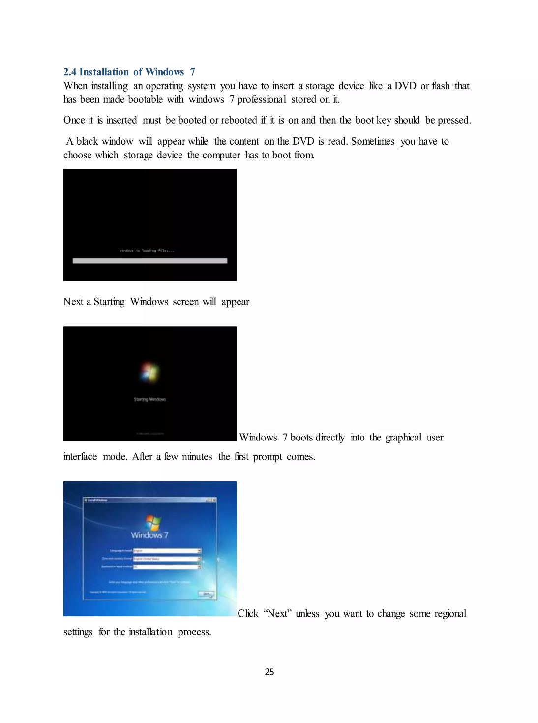

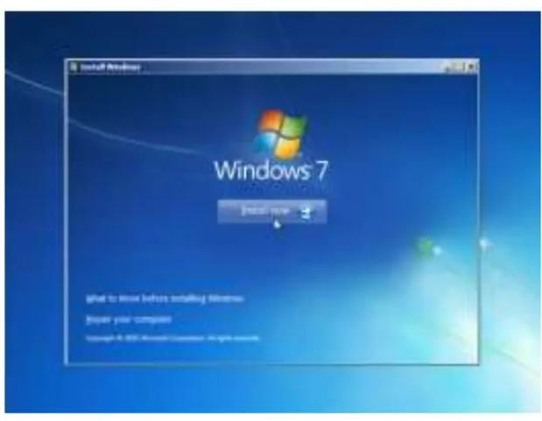

Click on install now.

Accept the terms and conditions and click next.

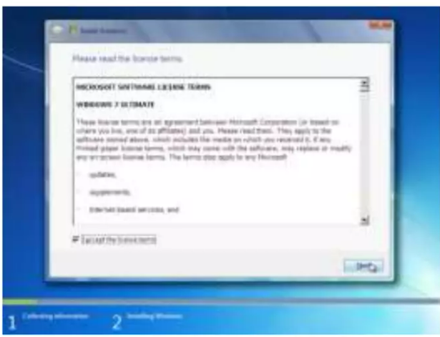

Press the “custom (advanced)” installation type button.

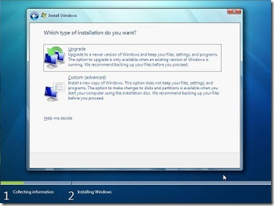

This is an important step as you need to select the drive where you would like to install Windows 7. Note that selecting a wrong partition will wipe out the data. Also, note that Windows 7 creates another small partition of about 200 MB if you are installing Windows 7 on an empty hard drive. The hidden 200MB partition will not be shown in the Windows Explorer!

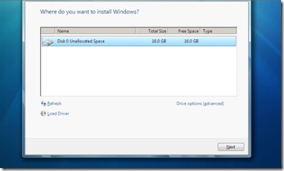

You can also format the selected partition by opening drive option and then choosing the **Format** option.

Click on the **Next** button to start the Windows 7 installation. Windows may restart many times during the installation and you need not worry about that.

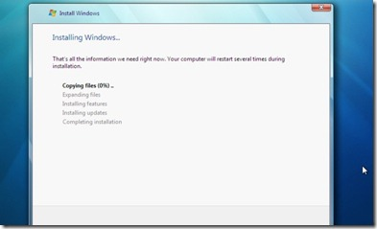

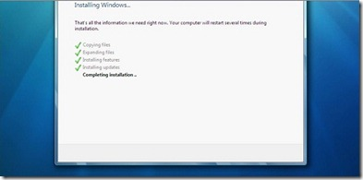

After completing the installation, Windows will give you the below screen to enter your username and password.

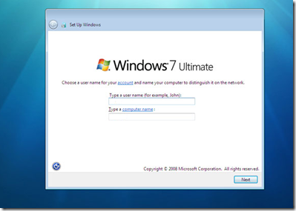

 In the next step you will be asked to enter the Product Key. Enter the key that you have got and click the **Next** button.

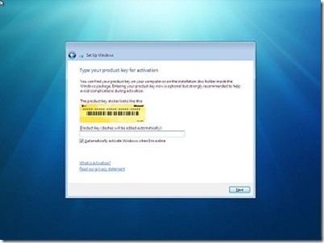

Here you need to select the Windows 7 update option. Click **Use recommended settings** option.

Select Time Zone, date and time and click **Next**.

In the next screen, you need to select the type of network. That is, choose between Home network, Work network and Public network.

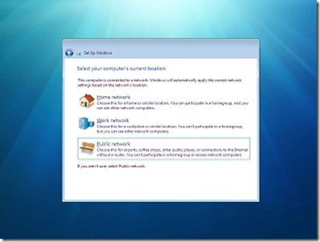

Finally, the setup will ask you to create a group depending on the type of Network you have chosen. If you are not sure, just skip as you can do it later as well.

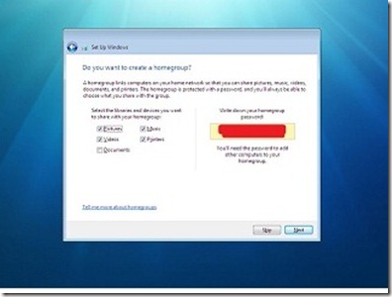

You will see the Windows 7 desktop. That is, you have successfully installed Windows 7 on your PC.

**Failed Boot:**

Computer system was not booting, it was requesting for a system image.

When not booting device is present in systems unit, then the operating system is corrupted.

Another problem faced was a user account being slow on a computer, and solved the problem by first removed the account and make it look like it's the first time its logging in on any computer.

We made sure that all the important files were stored on drive C and not in the account folder.

Removing the account you go to registry editor, run window type regedit.

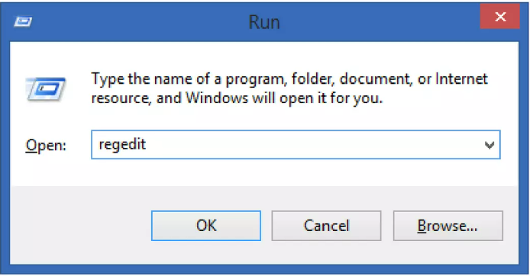

Then click on h key local machine, then software and then you go to Microsoft that under the software.

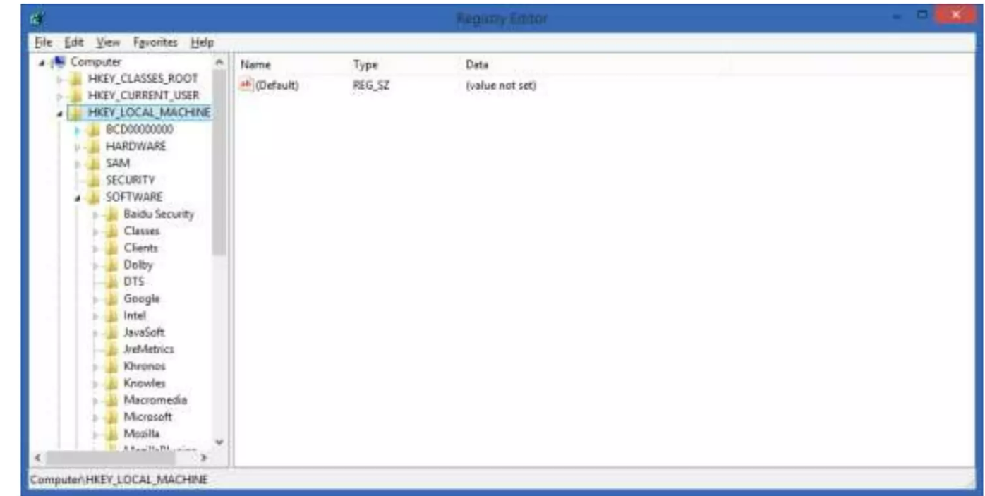

From Microsoft click on windows NT and after click on CurrentVersion.

Under CurrentVersion click the ProfileList.

Then look for folders/directories having many digits as their names and double click.

The information displayed will help you identify the count you are looking for.

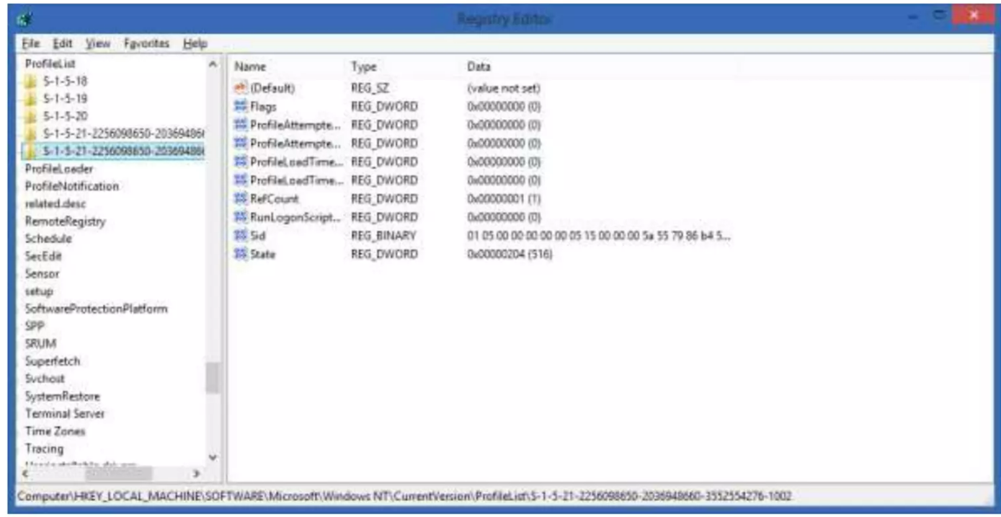

Installation of windows operating system on computer of staff members, and also other necessary important software e.g. jdk, Microsoft office, antivirus, WinRAR, WinZip, lynch Manually connected computers to wireless network.

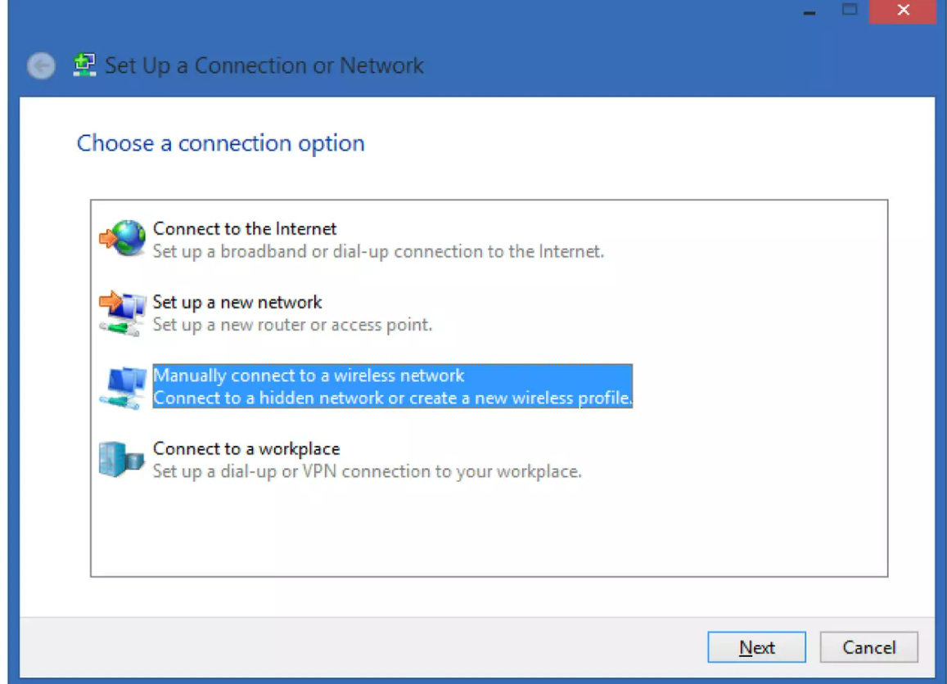

Choose security type of WPA2-Enterprise which has an encryption type of AES.

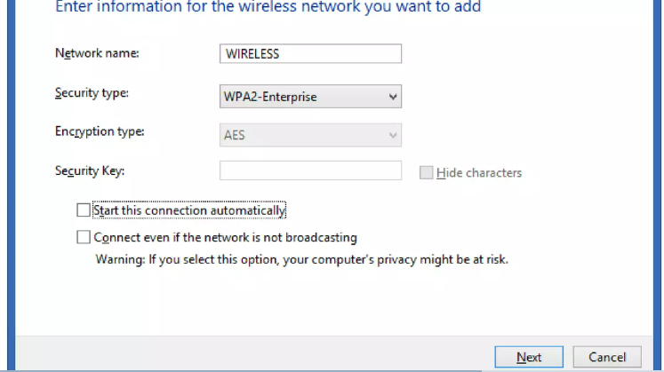

Changed connection settings, then security tab and go to settings,

Uncheck the validate by certificate box. Then go to configure and uncheck automatically use windows logon name.

When you go back to the security tab we select the advanced settings button and we specify the authentication mode, which we make user authentication and save credentials which the user must fill in.

Checked on the server through an administrative account that had active directory tool to check which computer are not in use so that we can give the repaired computer name as those saved on the server.

Printers that are on the server are added there and given in addresses hu a tool called "MQY”

They are given names and then added to the domain. We backed up email by moving the emails in the archive folder manually, through the control panel, then mail to the outlook web app to check whether we are sending them to the right archive folder. This is done when a user's inbox is full and he/she cannot receive any more emails We installed an operating system to a computer but first backed up data.

During the installation we didn't format or delete any partition, we installed straight away to drive C where the old operating system (Windows) was stored in a folder called "Windows. Old" which the computer created itself.

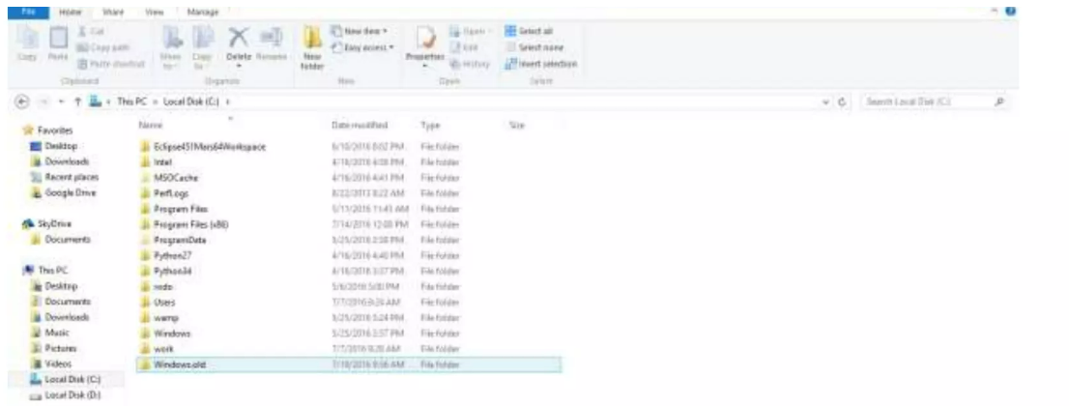 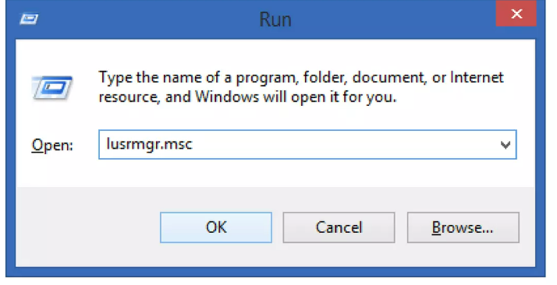

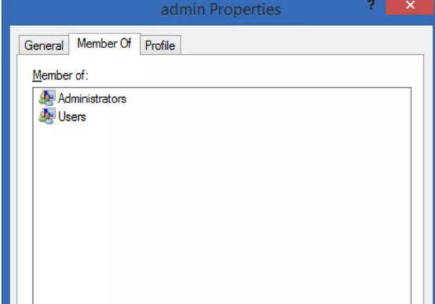

**WIDE AREA NETWORK**

This is a telecommunications network or computer network that extends over a large geographical distance.

Typically, a WAN consists of two or more LANS. Computers connected to a WAN are often connected through public networks, such as the telephone system. They can be connected through lease lines or satellites. The largest WAN in existence is the Internet.

We configured routers but not real tangible routers. We used a software called Cisco Packet Tracer that helped also design network infrastructures.

It helps us learn and understand how to configure routers, give network devices IP addresses Also helps us to know what kind of cables connected to different devices.

I noticed that straight-through cables connected to different devices e.g. switch to computer while the cross-over connect to similar devices e.g. router to router.

But discover something else that with the latest technology in switch one can used a straight- through cable to connect switch to switch.

I also accomplished a task of demystifying the OSI model and the TCP/IP model

The OSI model is comprised of 7 layers these are:

1. Application

2. Presentation

3. Session: This is layers controls dialogues (connections) between computers, it

establishes, manages and terminates connections between local and remote applications.

4. Transport: This is the fourth layer in the model; it holds PDUs called datagrams and segments.

5. Network: This is the third layer in the model: it uses ip addresses for communication and hold PDUs called packets. It handles the layer three communication and is responsible for translating physical address (mac addresses) into Logical addresses.

6. Data link: This is the second layer in the model, it handles the node-to-node transfer and it uses mac addresses and link logical control address. It also handles layer 2 (switching) communication. The PDUs at this level are frames.

7. Physical: The physical layer is the first layer; it specifies the electrical and physical specifications of the data connection. It holds a PDU called a bit.

# **The TCP/IP protocol stack**

This model has four layers. These are:

1. Network interface

2. Internet

3. Transport

4. Application

I also accomplished basic router and switch configurations, this included task like:

1. How to configure the hostnames

2. How to configure a few passwords like console passwords, vty passwords, enable passwords

3. Banners

4. How to configure interfaces

One of the LAN architecture designed (topology I used to configure eigrp)

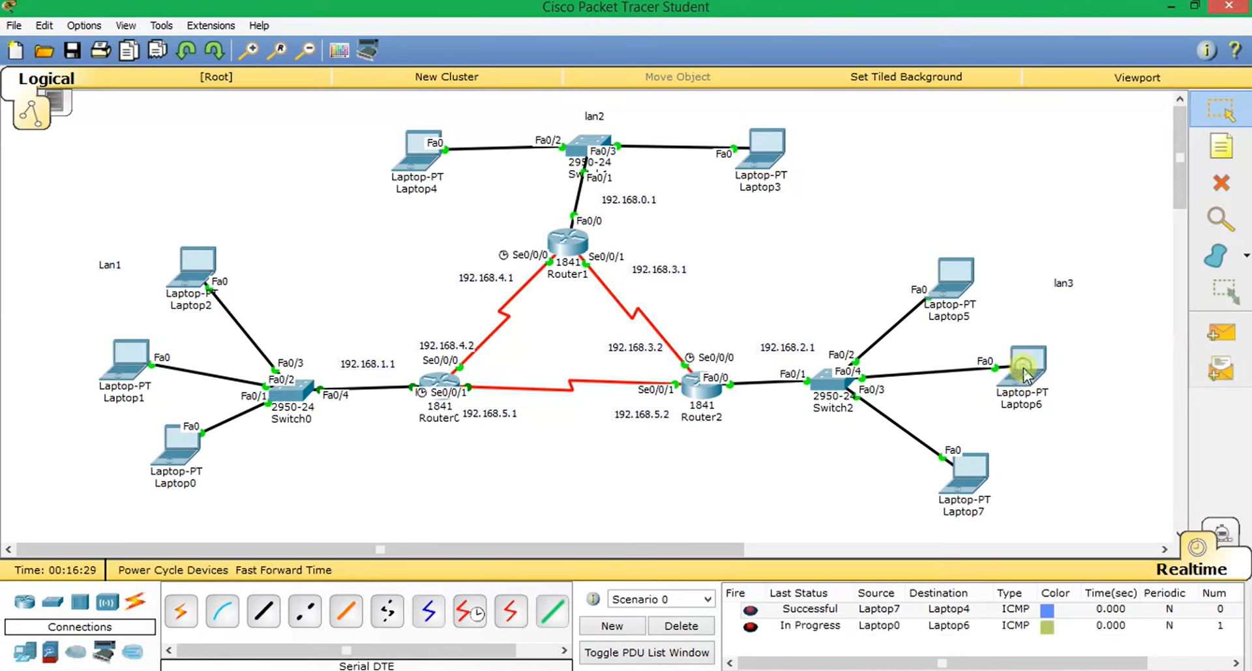

**VIRTUALISATION AND CLOUD COMPUTING**

URA uses large storage area networks to create storage pools and assigns them to different virtual machines in other words provides cloud storage for servers and users.

Storage :

There are different types of hard disks and some of the include;

* Serial Advanced Technology Attachment (SATA)
* Small Computer System Interface (SCSI)
* Solid-State Drive (SSD)
* Statistical Analysis Software (SAS)
* Nearline SAS (NLSAS)

# Advanced Technology Attachment

ATA (also known as IDE) is a disk drive implementation that integrates the controller on the disk drive itself. ATA is used to connect hard disk drives, CD-ROM drives and similar peripherals and supports 8/16-bit interface that transfer up to 8.3MB/s for ATA-2 and up to 100MB/s.

# Serial ATA (SATA)

This is an evolution of the parallel ATA physical storage interface. Because of the shortcomings of ATA, SATA was invented data transfer is done serially. It has a 7pin connector and data transfer rate is 150mb/s to 300mb/s. The differences between ATA and SATA are the data transfer modes, transfer rate and the interface module. SATA creates point-to-point connection.

# Small Computer System Interface (SCSI)

Data transfer is also done in parallel interface standard used by apple Macintosh computers and Personal Computers (PCs) and many UNIX systems. This interface is used to attach different devices to computers. Multiple devices can be connected to a single SCSI port. Its transfer rate is 80mb/s. it is an I/O bus rather than a simple interface. SCSI uses half duplex signal transmission mode.

# Serial attached SCSI (SAS)

Serial Attached SCSI, an evolution of parallel SCSI into a point-to-point serial peripheral interface in which controllers are linked directly to disk drives. SAS is a performance improvement over traditional SCSI because SAS enables multiple devices (up to 128) of different sizes and types to be connected simultaneously with thinner and longer cables; its full- duplex signal transmission supports 3.0Gb/s, which provides for faster throughout of data. In addition, SAS drives can be hot-plugged.

Multiple bits are wrapped into packets and it is able to move that single stream faster than parallel.

# Storage Area Networks and cloud storage

URA uses large storage area networks to create storage pools and assigns them to different virtual machines in other words provides cloud storage for servers and users. A storage area network (SAN) is a network which provides access to consolidated, block level data storage. A SAN typically has its own network of storage devices that are generally not accessible through the local area network (LAN) by other devices. The cost and complexity of SANS dropped in the early 2000s to levels allowing wider adoption across both enterprise and small to medium-sized business environments.

Cloud storage is a model of data storage in which the digital data is stored in logical pools, the physical storage spans multiple servers (and often locations), and the physical environment is typically owned and managed by a hosting company.

We learnt that in virtualization three factors are put under consideration and these are:

1. The computer and its components

2. Virtual desktop infrastructure (VDI)

3. Redundancy

# RAIDS

RAID is redundant array independent disk. A number of disks are aggregated to form a single logical disk. Some of the raids are; Raid 0, raid 1, raid 10, raid 3, raid 4, raid 5 and raid 6. Below are the RAIDS used at URA:

# RAID 0

RAID 0 consists of striping, without mirroring or parity. The capacity of a RAID 0 volume is the sum of the capacities of the disks in the set, the same as with a spanned volume. There is no added redundancy for handling disk failures, just as with a spanned volume. Thus, failure of one disk causes the loss of the entire RAID 0 volume, with reduced possibilities of data recovery when compared to a broken spanned volume. Striping distributes the contents of files roughly equally among all disks in the set, which makes concurrent read or write operations on the multiple disks almost inevitable and results in performance improvements. The concurrent operations make the throughput of most read and write operations equal to the throughput of one disk multiplied by the number of disks. Increased throughput is the big benefit of RAID 0 versus spanned volume, at the cost of increased vulnerability to drive failures.

RAID 1

It implements striping technique where by data is written across all disks that is, each disk has a character of data being recorded. Used for booting because of its high read speeds. The minimum number of disks to participate in the raid is two. (RAID, 2016)

**VBLOCK SYSTEM**

Vblock systems from VCE simplify all aspects of IT and enable organizations to achieve better business outcomes faster. Seamlessly integrating best in-class compute, network, and storage technologies from industry leaders Cisco, EMC, and VMware, Vblock system provide dynamic pools of resource that can be intelligently provisioned and managed to address changing demands and rapidly shifting business opportunities.

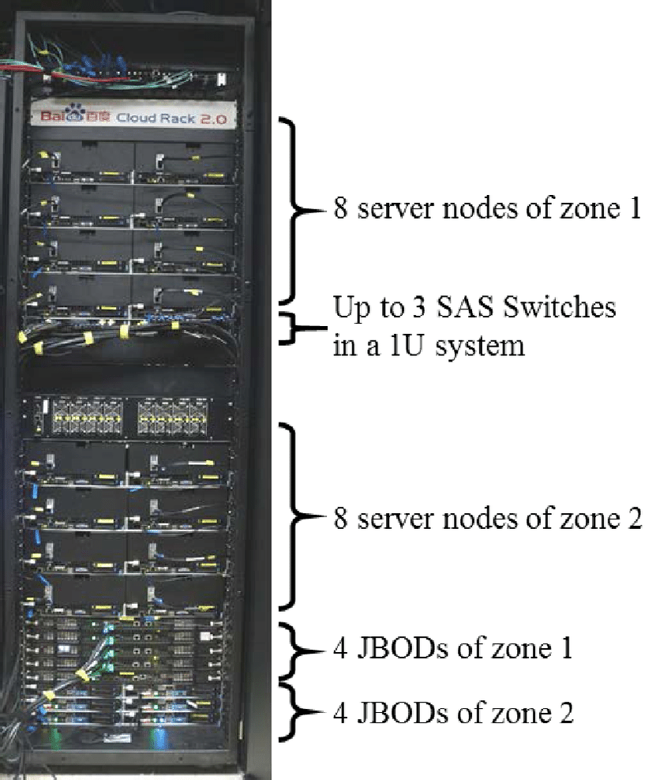

**LOCAL AREA NETWORK**

# CABLES :

I looked at data cables. A data cable is a medium that allows baseband transmission (binary 1,0s) from the transmitter to the receiver. Types of network cable are coaxial cable, optical fibre cable and twisted pair.

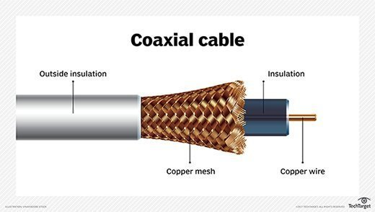

**Figure: coaxial cable**

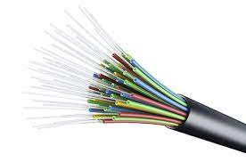

**Figure: Fibre Optical cable**

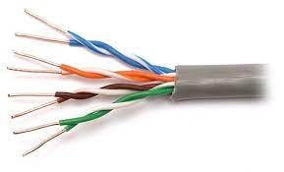

**Figure: Unshielded Twisted pair cable**

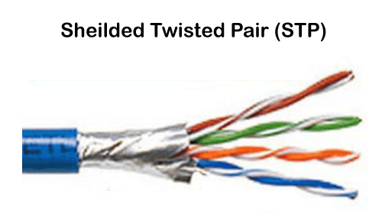

**Figure: Shielded Twisted pair cable**

**Note:** Emphasis was given to twisted pair of cable. Twisted pair cabling is a type of wiring used for communications in which two conductors of a single circuit are twisted together for the purposes of improving electromagnetic compatibility.

# LAN:

There are two types of LANS;

* Ethernet LANS
* Wireless LANS

# Ethernet LANS

Ethernet refers to a family of LAN standards that together define the physical and data link layers of wired LAN technology.

It defines the cabling, the connectors on the ends of the cables, the protocol rules and everything else required to create an Ethernet LAN.

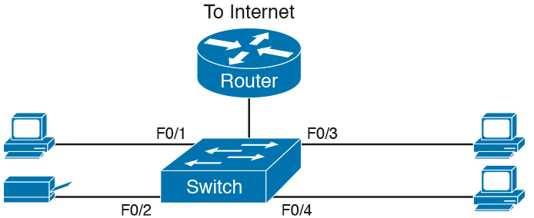

LAN basically runs from the machine to the data socket on the wall then through the trunks to the patch panel and then to the patch panel. I started by inserting UTP cables in a data module, and that would runs from there to the patch panel. The connection/termination used must be the same at both ends (module end and patch- panel end).

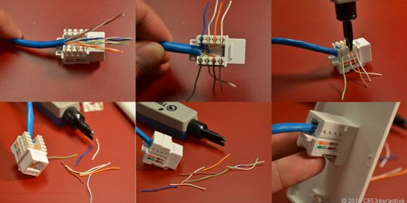

**WLAN**

In a constrained space like a home, school, computer lab, campus, or office building, a wireless LAN (WLAN) connects two or more devices using wireless communication to create a local area network (LAN). Users are able to wander throughout the area while still being connected to the network thanks to this. A WLAN can also offer access to the larger Internet via a gateway.

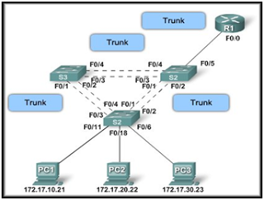

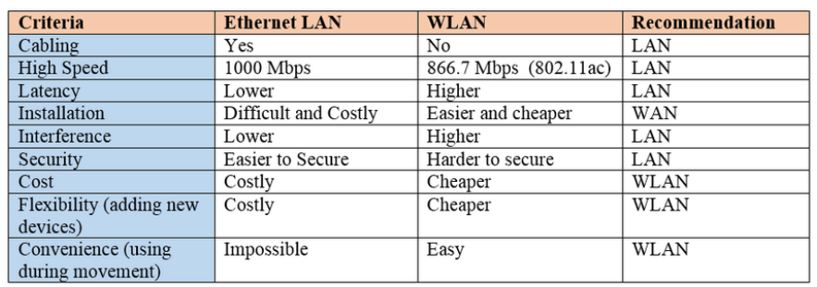

**DATA ACQUISITION SYSTEM**

Individual sensors with the required signal conditioning, data conversion, data processing, multiplexing, data handling, and related transmission, storage, and display technologies make up a typical data acquisition system.

The essential subsystems can be joined together in order to improve the system's performance, handling capacity, and cost. Typically, analogue data is collected and converted into digital form for processing, transmission, display, and storage purposes.

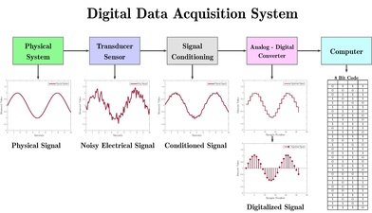

The features of the analogue data and the processing done affect the data acquisition system's characteristics.

A wide classification of data collecting systems into two types is based on the environment.

1. Those suited for favourable settings (low electromagnetic induction and RF interference)

2. Those made for dangerous environments

The former group could consist of lock-in amplifiers and mass spectrometers for routine measurements in research, as well as test systems for gathering long-term drift data on zeners and high calibration test instruments. These systems are made to handle jobs that are more focused on taking precise measurements than on issues with maintaining the integrity of analogue data. Specific safeguards for maintaining the integrity of analogue data under adverse circumstances are included in the classifications of data gathering systems. These measuring circumstances can be found in industrial process control systems, turbovisous electrical power systems, and aircraft control systems.

The majority of these hostile measuring environments demand equipment that can operate in a wide temperature range, effective shielding, redundant pathways for crucial measurements, and intensive processing of the digital data acquisition system.

On the other hand, laboratory measurements use high sensitivity and precision instruments with a narrow temperature range and significantly less electrical noise for improved accuracy and resolution.

The following are the key considerations while setting up a data acquisition system.

* Resolvency and accuracy
* Channels to be seen in number
* Digital or analogue signal
* Single or many channels
* Samples per channel per second
* Each channel's signal conditioning requirements
* Cost

# **Objectives of Data Acquisition System:**

* It must acquire the necessary data, at correct speed and at the correct
* Use of all data efficiently to inform the operator about the state of the
* It must monitor the complete plant operation to maintain on-line optimum and safe operations.
* It must provide an effective human communication system and be able to identify problem areas, thereby minimising unit availability and maxi­mising unit through point at minimum cost.
* It must be able to collect, summarise and store data for diagnosis of operation and record purpose.
* It must be able to compute unit performance indices using on-line, real-time data.
* It must be flexible and capable of being expanded for future require­
* It must be reliable, and not have a down time greater than 0.1%.

Data acquisition applications are usually controlled by software programs developed using various general purpose programming languages such as Assembly, BASIC, C, C++, FORTRAN, JAVA etc.

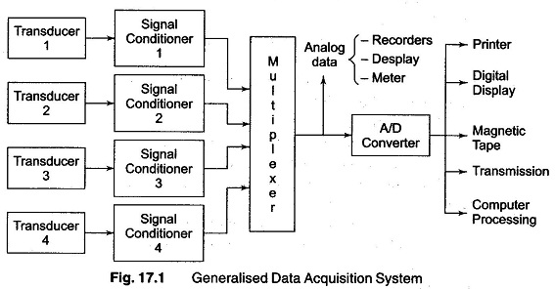

**Lessons and Experiences**

During my IT training, I have gained several valuable learnings that have had a significant impact on my professional growth and development. Here are some of the key learnings I have acquired:

Technical Skills Enhancement: The training program has allowed me to acquire and enhance a wide range of technical skills relevant to the IT field. I have gained proficiency in various software applications, programming languages, network configurations, database management, cybersecurity principles, and other IT tools and systems. These technical skills have expanded my capabilities and increased my effectiveness in performing IT-related tasks.

Problem-Solving Abilities: Through the training program, I have learned effective problem-solving techniques specific to the IT domain. I have developed a systematic approach to analyze and resolve technical issues, troubleshoot software and hardware problems, and identify root causes. This skill has enabled me to become more resourceful and efficient in overcoming challenges in my work.

Understanding of IT Concepts and Principles: The training has provided me with a solid foundation in fundamental IT concepts and principles. I have gained a deeper understanding of topics such as data structures, algorithms, computer architecture, network protocols, and software development methodologies. This knowledge has given me a broader perspective on IT and enhanced my ability to grasp complex concepts and adapt to evolving technologies.

Communication and Collaboration Skills: The training program has emphasized the importance of effective communication and collaboration within IT teams and with stakeholders. I have learned how to articulate technical ideas clearly and concisely, present information in a meaningful way, and actively listen to others. These skills have improved my ability to work in a team, exchange ideas, and collaborate on projects effectively.

Adaptability and Continuous Learning: One of the most valuable lessons from the IT training is the importance of adaptability and continuous learning in the rapidly evolving IT industry. I have realized that technology is constantly changing, and it is crucial to embrace lifelong learning to stay relevant. The training has instilled in me a mindset of curiosity and a commitment to staying updated with emerging trends and advancements.

Awareness of IT Security: The training program has raised my awareness of IT security risks and the importance of maintaining robust security measures. I have learned about common cybersecurity threats, best practices for data protection, and the significance of following security protocols. This knowledge has made me more vigilant and proactive in safeguarding IT systems and sensitive information.

Professional Development: The IT training has reinforced the value of professional development and continuous improvement. It has encouraged me to seek further learning opportunities, pursue certifications, attend industry events, and engage in networking activities. I understand the importance of investing in my professional growth to remain competitive in the IT field.

Overall, the IT training program has equipped me with the necessary technical skills, problem-solving abilities, and foundational knowledge to excel in my career. It has fostered a mindset of adaptability, continuous learning, effective communication, and security consciousness. I am grateful for the opportunities provided by the training and look forward to applying these learnings to contribute positively to my organization and further my personal and professional growth in the IT field.

**Conclusion**

In conclusion, as a trainee, this IT training report has provided me with a valuable opportunity to reflect on my learning journey and the outcomes of the training program. Throughout the report, I have discussed the objectives of the training, the topics covered, the methodologies employed, and my overall experience.

The training program has been instrumental in enhancing my technical skills and knowledge in various IT domains. Through hands-on exercises, practical examples, and interactive sessions, I have gained a deeper understanding of essential tools, systems, and concepts. I am now equipped with the necessary expertise to perform my job more effectively and contribute to the organization's success.

Moreover, the training program has fostered a sense of confidence in my abilities. I have developed a greater comfort level in using different IT tools and technologies, which has positively impacted my efficiency and productivity. The practical applications and real-world scenarios presented during the training have enhanced my problem-solving skills and critical thinking abilities.

I am particularly appreciative of the supportive and knowledgeable trainers who facilitated the training sessions. Their expertise, patience, and willingness to address our queries have been invaluable in creating a conducive learning environment. The interactive nature of the training allowed for effective knowledge transfer and encouraged active participation.

Moving forward, I recognize the importance of continuing my learning journey in the IT field. Technology evolves rapidly, and staying up-to-date with the latest trends and advancements is essential. I intend to capitalize on the foundation established during this training program by seeking further learning opportunities, exploring relevant certifications, and engaging in continuous professional development.

I would like to express my gratitude to the organization for providing me with this valuable training opportunity. It has not only expanded my technical skills but also instilled in me a passion for ongoing learning and growth. I am confident that the knowledge and experience gained through this training program will greatly contribute to my future success in the IT field.

In conclusion, the IT training program has been a transformative experience, empowering me with the necessary skills, knowledge, and confidence to excel in my role. I am excited about the potential to apply what I have learned and make a positive impact within the organization. I look forward to embracing future opportunities for growth and continuing my professional development in the dynamic world of IT.

THANKYOU.